Determine the graph of the equation and write in general form. Graph Results

1) 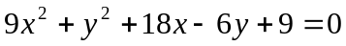
2) 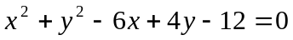
3) 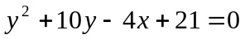
4) 